IT 511: Object Oriented Application Development
Module Two: Introduction to Object-Oriented Programming Concepts
ZyBooks: Programming in Java: Early Objects
Chapters 3 & 4
3//27/22

Learning Objectives

- Recognize and apply basic methods and classes to address computational problems
- Construct pseudocode for a collection manager program

Textbook Sections

Chapter 3: Basic Objects - Part 2
- 3.1 Identifiers
- 3.2 Arithmetic Expressions (int.)
- 3.3 Floating Point (double)
- 3.4 Comments and White Space
- 3.5 Calling Methods
- 3.6 Constructing Objects
- 3.7 Accessors and Mutators
- 3.8 Reading API Documentation
- 3.9 Debugging
- 3.10 Basic Graphics
- 3.11 Style Guidelines
- 3.12 Java Examples: Salary Calculation with Variables

Chapter 4: Basic Methods + Classes
- 4.1 Classes: Introduction
- 4.2 Method Basics
- 4.3 Parameters
- 4.4 Return
- 4.5 Reasons for Methods
- 4.6 Unit Testing (classes)
- 4.7 The “This” Implicit Parameter
- 4.8 Javadoc for Classes

Module Overview

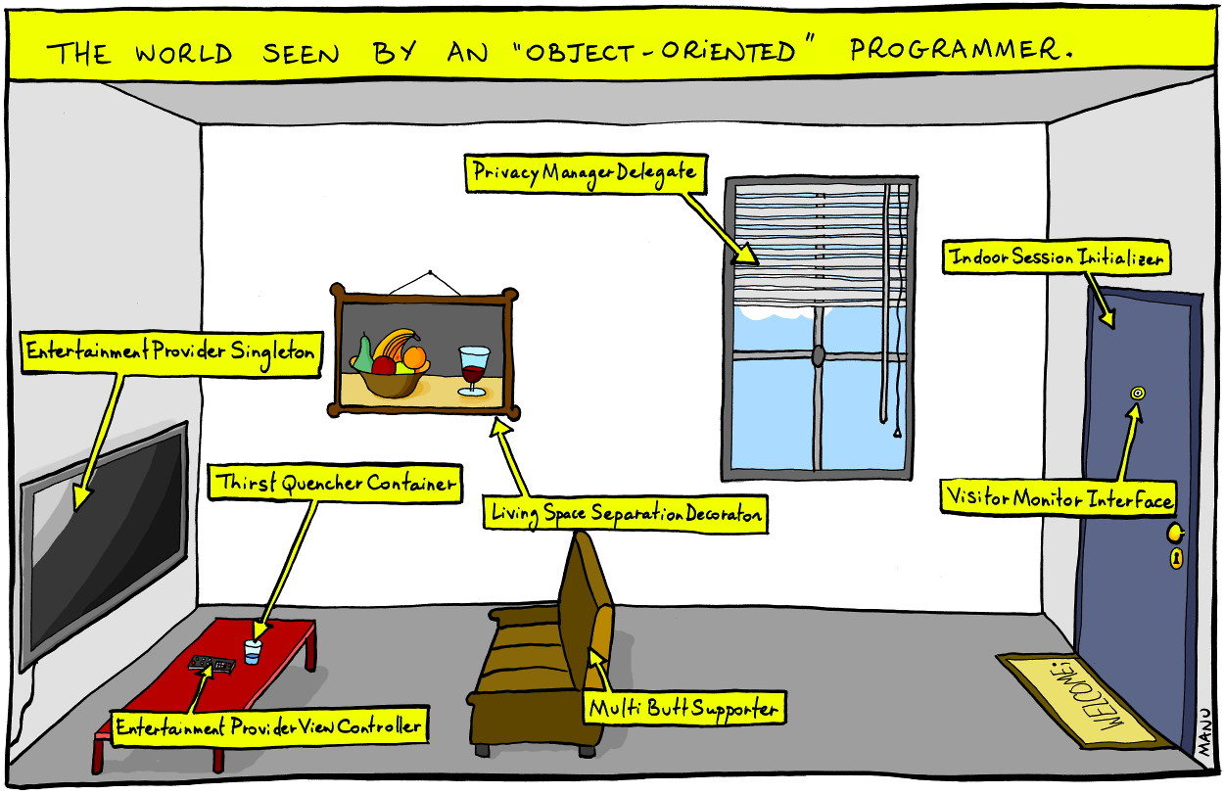
Image 2.1: The World Seen by an Object-Oriented Programmer
(Image source: Bonkers World, Manu Cornet)
Note how common objects are perceived by their potential functions. Can you similarly redefine the objects you encounter in the course of your day? This can help you practice “thinking O-O.”
In Module One, you began your work with object-oriented programming by considering the qualities that distinguish it as a paradigm and the drivers that led to its development. You also began practicing some of the basic coding structures of object-oriented programming in the zyBooks learning resource for the course. In Module Two, you will take the next step in building your knowledge and skills by focusing on the fundamental concepts in object-oriented programming that will lay the foundation for your work in this course.
At its core, object-oriented programming allows for changes in conditions or states to address problems. This quality is reflected in basic terms that apply across the object-oriented paradigm. An object-oriented program creates objects that are present in a particular state but subject to change. Objects are modeled by attributes that define and characterize them. Objects interact with each other, passing messages that may lead to changes to their states. The behaviors of objects within these interactions are modeled as methods. As you build object-oriented programs and learn to think with this paradigm, note that your work typically consists of affecting the attributes of objects through the methods developed in the program. Life functions in a similar manner: Think of how your attributes, including in “classes” that range from clothing to mood, may be affected by something as simple as the weather.
An algorithm is a set or list of instructions for carrying out a process step by step. A recipe in a cookbook is an example of an algorithm. The recipe includes the requirements of ingredients and the method of cooking them until you end up with a prepared dish. For object-oriented programs, a procedure explicitly stating the steps leading to the solution is represented as a method.
In the zyBooks activity for Module Two, you will look more closely at the key component of object-oriented programming—objects. Note that in this paradigm object implies not only a state but an action; it is a present condition that can be used to bring about a change. An object in this sense is defined by its potential to solve a problem. In the cartoon above, for instance, the glass of water is a “thirst quencher container,” while the blind on the window is defined by its potential to affect privacy. In the zyBooks selection for Module Two, you will see how this concept of problem-solving potentiality is reflected in the coding structures that define both the attributes of objects and the methods by which they act, interact with other objects, and produce solutions.
Module Two also provides the opportunity for you to begin developing an object-oriented “collection” program that may operate in a manner that parallels the program you will create for your final project. In the first stepping stone lab, you will develop pseudocode for a program to help a friend manage a collection. By composing pseudocode, you will think through a collection program, including its basic structure and potential functions. For more information on this assignment, including the grading rubric, see the Stepping Stone Lab One Guidelines and Rubric document.
In the modules to come, you will work through a series of stepping stones that allow you to practice the key coding structures and concepts that will help you create a successful final project in this course and prepare you to approach other problems that may call for an object-oriented solution in your life and work. You are learning to think with the unique combination of flexibility and clarity the object-oriented paradigm provides.

